**Ideation Phase**

**Define the Problem Statements**

|  |  |
| --- | --- |
| Date | 19 august 2025 |
| Team ID |  |
| Project Name | ahopEZ One-Stop Shop For Online Purchases |
| Maximum Marks | 2 Marks |

**Customer Problem Statement Template:**

To define the core problems customers face while searching for products online, and use those insights to guide the development of shopEZ.

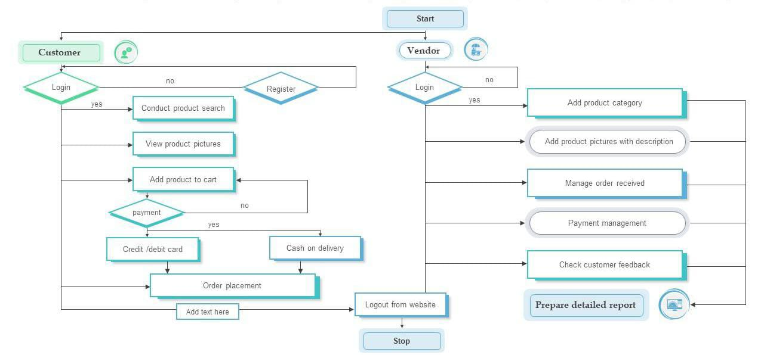

|  |  |  |  |  |  |
| --- | --- | --- | --- | --- | --- |
| **Problem Statement (PS)** | **I am (Customer)** | **I’m trying to** | **But** | **Because** | **Which makes me feel** |
| PS-1 | shopEZ customer I order clothing frequently. | Buy more products. | The products are delivering within a week it will be more helpful if they send within 3 days. | I want to sell at my place. | Frustrated. |
| PS-2 | shopEZ customer I face problem in login. | I want to login but I am unable to login | Need to login to purchase different categories. | I want to get the products | Which makes me feel frustrated. |